Safety Recall Notice

Some SE BICYCLES were sold equipped with disc brakes and a front quick release lever that can come into contact with the front disc brake when improperly adjusted or left open while riding. An example of a bicycle with a front quick-release cam lever that is able to be opened far enough to create this potential contact is shown in Figure 1 below. An example of a bicycle with a front quick-release cam lever that does not have the potential for contact with the disc brake is shown in Figure 2. When a quick release like the one shown in Figure 1 is improperly adjusted or left open on a bicycle which also has a front disc brake, the quick release lever can become caught in the front disc brake assembly. If this happens, the front wheel could separate or come to a sudden stop and the rider could lose control of the bicycle posing a serious risk of injury.
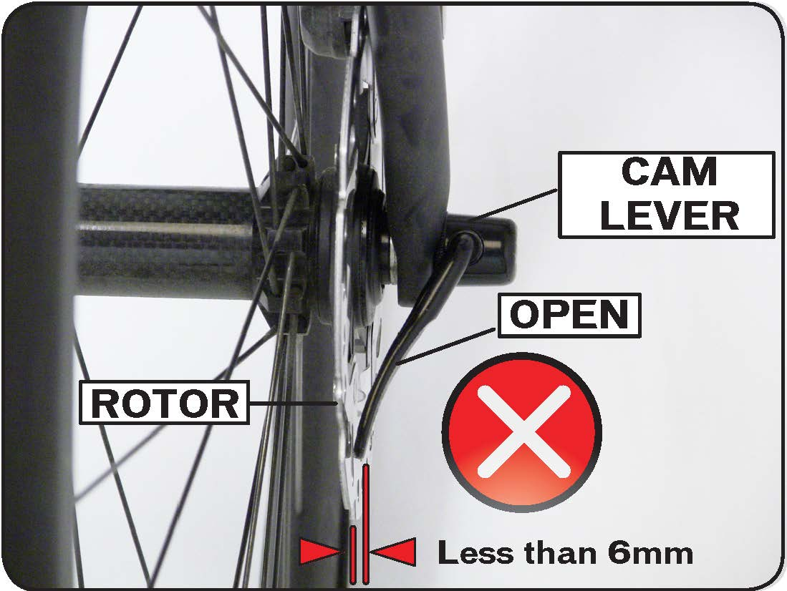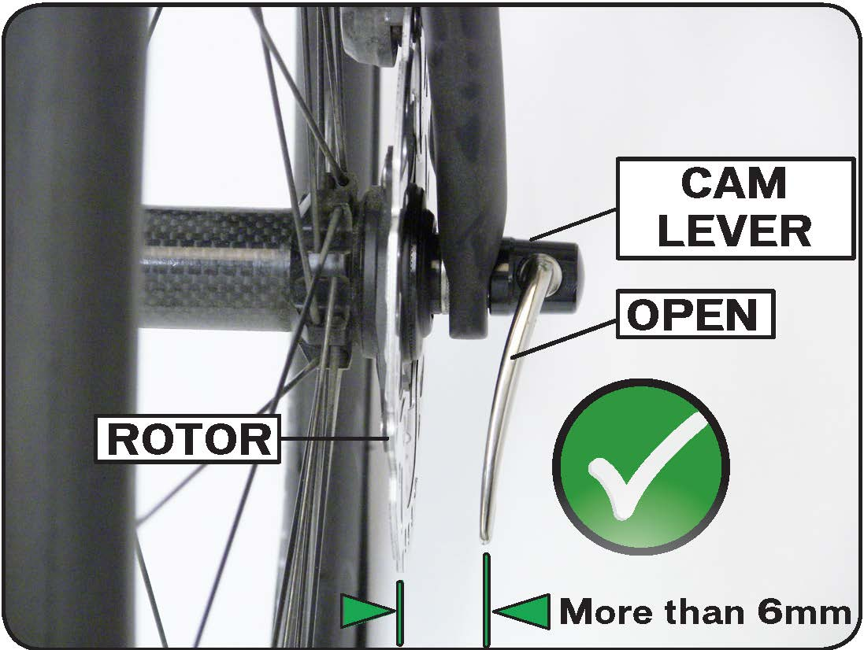
Figure 1. Quick-release lever with potential for contact Figure 2. Quick-release lever with adequate clearance

AFFECTED MODELS: Any SE bicycle equipped with disc brakes and a front quick release lever that can contact the disc brake assembly when fully opened is subject to this recall. Bicycles with front quick-release cam levers that have a clearance of at least 6 millimeters, which is the width of a #2 pencil, between the edge of the lever in its most open position and the disc brake rotor are not considered affected models. If you can pass a #2 pencil between a fully opened quick release lever and your bike’s disc brake rotor, your bike is not an affected model. For a video demonstration of how to check this, please visit quickreleaserecall.com.

WHAT SE BICYCLES WILL DO FOR OWNERS OF A RECALLED BICYCLE: If you own a bicycle that is subject to this recall, SE will provide you—through your SE retailer—a free replacement quick release, including free installation. Please see your local SE retailer or contact Advanced Sports International (parent company of SE Bikes) with questions at 888-286-6263.

